**Project Planning for Willy’s Widget Company’s Spartan**

**Team 3 (Spartan)**

**REVISION HISTORY**

|  |  |  |  |  |
| --- | --- | --- | --- | --- |
| V. No. | Revision Description | Modified  By | Modification Date | Comments |
| 0.1 | Initial draft created | SungEun Kim | 2014/05/23 |  |
| 0.2 | Teamwork | Tommy Park | 2014/05/26 |  |
| 0.3 | Reflecting the mentor’s comments | Vijay  SungEun Kim  Sun | 2014/05/28 |  |
| 0.5 | Updated all sections.  (Formatting, corrections, font etc)  Removed test plan | Vijay | 2014/05/29 |  |
| 0.6 | Teamwork  Fixed for Initial Presentation | All | 2014/05/29 |  |

Contents

1. Project Scope 4

1.1 Project Name 4

1.2 Project Goal & Strategy 4

1.3 Duration 4

1.4 Success Criteria 4

2. Development Process 5

2.1 Agile Process 5

2.2 Activity Definition 6

2.3 Role Definition 7

2.4 Sprint Plan 9

3. WBS & Estimation 10

4. Time Log 11

4.1 Time Log Category 11

4.2 Time Log vs. WBS Work Item 11

# Project Scope

## 1.1 Project Name

Willy’s Widget Company’s Spartan

## 1.2 Project Goal & Strategy

The project goal is development of Willy’s Widget Company’s Spartan based on a robot-assisting semi-automated warehouse system. This system should process integrated customer orders which would be placed in a laptop.

Major values could be added by this project are

* Fast delivery time in customer’s perspective
* Correct and easy management of warehouse inventories in manager’s perspective
* Lowering worker’s load in worker’s perspective
* Lowering labor cost in stockholder’s perspective

Although above all values can be major goal of our project, we will basically focus on the correct and easy management of warehouse inventories because system’s feature extension should be based on correctness. Moreover, we have only 5 weeks for developing system. Of course, we will review if this assumption is correct in each iteration splint.

In addition, customer order system will be limited to laptop in this project, but we will design the system to be extended for mobile environment. The reason of this is that mobile handset usage is increasing more and more. This can increase system extensibility.

## 1.3 Duration

- Draft Plan and ADS in Korea: May 12th ~ May 26th

- Product Analysis/Design/Implementation: May 27th ~ Jun 27th

## 1.4 Success Criteria

- To develop & deliver reliable and extensible WWC Spartan on time (Jun 27th).

- To apply the practices learned from the lectures to this project.

# Development Process

We develop using Agile Method to allow maximum flexibility and control.

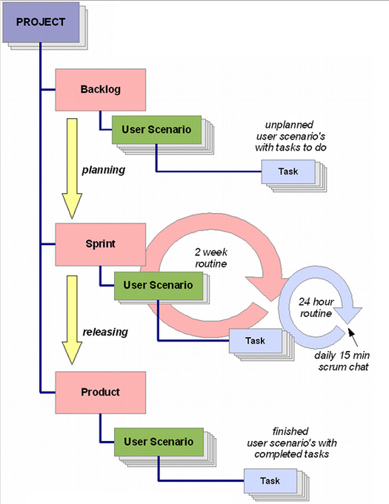

2.1 Agile Process

Agile takes a flexible approach to development. A high priority is “to satisfy the user through early and continuous delivery of valuable software.”

Because of the following reasons, Agile methodology is chosen for this project

* User requirements are not completely clear.
* New technologies and new hardware
* Requirements may be changed in the course of the project.

For achieving the best result, we need to have constant contact with customer using email or conference call etc.

2.2 Activity Definition

| **Name** | **Description** |
| --- | --- |
| Project | * Embrace all activities the team to deliver goal/deliverable. |
| Scenario | * Compact descriptions of the expected behavior of the application. * Deduced from Use Cases * All user scenarios together describe the complete way the application working |
| Backlog | * Contains all user scenarios that has not yet planned |
| Task | * Piece of work that one of the team members needs to fulfill to accommodate a user scenario. * Each task belongs to only one user scenario. * Task larger than Scrum term will be spilt in a smaller task as the goal will be complete them within Sprint * Task can contain: * Description * Links to discussions, file attachments * Link to a demo/ test environment * Optional link to a bug tracking system * The planned amount of hours to realize * Actual number of hours it took to finish |
| Sprint | * We will have 3 sprints (2 sprints of 2 week each, 1 sprint for 1 week). * When all sprints are released, the project is complete and the application is ready. |
| Sprint Planning Meeting | * The planning is the meeting before the start of each sprint. * Team selects a set of user scenarios which the highest priority that the team should be able to implement within the fixed amount of time the sprint will take. * This is the process of moving user scenarios from the backlog to the sprint. |
| Scrum Meeting | * Scrum meeting is a daily 15mintes chat, usually at 5:00 PM * Only the Scrum master and Developers participate in this meeting: * What’s done? * What will do? * Any issues? |

2.3 Role Definition

For defining role, we separate the system as following diagram.

* Supervisor Application
* Customer Application
* Warehouse Server
* Warehouse Firmware
* Robot Firmware



| **Name** | **Description** |  |
| --- | --- | --- |
| Product Owner | * Represents the voice of the customer and is accountable for ensuring that the Team delivers value to the business. * Scrum teams should have one Product Owner and while they may also be a member of the Development Team, it is recommended that this role not be combined with that of Scrum master * Write user stories * Prioritize user stories * Accepting user stories after concluding a iteration | * Anthony Lattanze |
| Scrum master | * Scrum master is not a team leader but acts as a buffer between the team and any distracting influences. * Ensures that the Scrum process is used as intended. * Question the Project Owner to ensure they fully understand the requirements of the Product owner and end-user * Host the iteration meetings * Help the product owner participate defects and even make sure there is time reserved to fix bugs during the iteration. | * Sungeun Kim |
| Team | * Customer Application * Communication Protocol * User Interface | * Kyung Lang Park |
| * Supervisor Application * Database Scheme Define * Communication Protocol * User Interface | * Jinyoung Du * Vijay Rachabattuni |
| * Warehouse Server * Robot Control * Station Control * Order Processing | * Sungeun Kim * Byungseon Shin * Jugwan Eom |
| Client Stakeholder | * Contribute with User Scenarios. * One or more persons from the client will be involved in reviewing each completed iteration | * Anthony Lattanze * Philip Bianco |

## 2.4 Sprint Plan

During the first Sprint, we will design and implement interfaces of core functionalities of placing an order. At second Sprint, we will implements the manager features of the System.

At the final periods, we will prepare demo scenario based on Sprint results.

| **Period** | **Task** | **Deliverable** |
| --- | --- | --- |
| 5/12~ 5/25 | Project Scoping | Project Plan  Backlog |
| 5/26 ~ 6/6 | **Sprint #1**  Core-Functionalities | * Define communication protocol between Customer Application and Warehouse Server * Define Database Schema for Supervisor Application * Inventory Management Function * Implement Robot moving based on sensor and motor control * Processing H/W signal from Warehouse |
| 6/6 | **Sprint#1 Demonstration** | |
| 6/9 ~ 6/20 | **Sprint #2**  Monitor Features  + Nice to have features | * Update inventory status by Supervisor * Update order status by Warehouse Server * Implement Client Interface and Supervisor interface * Implement failure recovery function |
| 6/20 | **Sprint#2 Demonstration** | |
| 6/23 ~ 6/27 | Product | * Warehouse System, Customer Application, Supervisor Application, * User Guide, Supervisor Guide |
| 6/27 | **Product Demonstration** | |



# WBS & Estimation

High-level functional requirements are captured into work breakdown structure and tasks are estimated using a **Wideband Delphi** technique.

Detailed estimation report is below excel sheet.



# Time Log

## 4.1 Time Log Category

Time log category is as below :

* Planning
* Requirements & Analysis
* Design
* Implementation
* Integration
* Testing



## 4.2 Time Log vs. WBS Work Item

Each work item of WBS will has one attribute corresponding to time log category. So, we update and accumulate time log by WBS excel sheet. Finally, accumulated time log will be compared to estimated time in planning phase.